Hybrid ViT–CNN for Robust, Real-Time Air Pollution Detection and Analysis in Smart Cities

Highlights
- Beyond Single-Model Limits: We introduce a novel hybrid architecture that successfully bridges the gap between searching for local anomalies (CNN) and understanding city-wide trends (ViT).
- Instant Awareness: Unlike traditional cohesive systems that lag, our model processes multi-zone sensor data to update Air Quality Index (AQI) predictions every 5 seconds.
- Realistic Urban Simulation: We moved beyond static datasets by engineering a dynamic simulation engine that mimics the chaotic nature of real-world pollution, from rush-hour traffic to sudden industrial spikes.
- Life-Saving Alerts: A built-in, proactive warning system ensures that hazardous air quality triggers immediate notifications, potentially protecting vulnerable populations in real-time.

Abstract
Effective air quality monitoring is essential for public health, yet current systems often struggle to distinguish between temporary localized spikes and persistent city-wide pollution trends. This study presents a practical hybrid deep learning system that addresses this limitation by combining Convolutional Neural Networks (CNN) with Vision Transformers (ViT). We utilize the CNN component to detect immediate, localized anomalies, while the ViT component analyzes broader spatial relationships to provide global context. By integrating these models through a weighted fusion mechanism, the system achieves a balance between high sensitivity to sudden pollution events and stability against sensor noise. We developed a complete full-stack prototype to validate this approach, simulating realistic urban sensor data to generate real-time Air Quality Index (AQI) predictions. The results indicate that this hybrid architecture offers more reliable and robust alerts than standalone models, providing a practical foundation for next-generation smart city monitoring solutions.

Keywords: Air Pollution Monitoring, Convolutional Neural Networks (CNN), Vision Transformers (ViT), Hybrid Deep Learning, Smart Cities, Internet of Things (IoT), Real-time Alert System.

1. Introduction
We are living in an era of unprecedented urbanization, but this rapid growth causes a critical environmental challenge: deteriorating air quality. The World Health Organization (WHO) identifies air pollution as a leading environmental cause of disease and premature death, emphasizing the urgent need for effective monitoring systems. However, traditional monitoring infrastructure often lacks the spatial resolution and real-time responsiveness required to protect public health effectively [6].

The current landscape of air quality prediction is divided between classical statistical models and emerging deep learning approaches. While statistical methods like ARIMA have served us well for linear trend analysis, they frequently falter when faced with the complex, non-linear dynamics of urban pollution [8]. This limitation has driven a surge in deep learning research, particularly utilizing Long Short-Term Memory (LSTM) networks and Convolutional Neural Networks (CNNs) [4], [5].

However, a significant knowledge gap persists in the literature. Standard CNNs excel at detecting local spatial features—such as a sudden plume of smoke from a factory—but often struggle to contextualize these events within broader, city-wide temporal trends [1]. Conversely, recent innovations using Vision Transformers (ViT) have demonstrated remarkable ability in capturing global dependencies and long-range patterns through self-attention mechanisms [2], yet they can sometimes "smooth out" critical, high-frequency anomalies that require immediate action [3], [10].

Furthermore, the integration of these sophisticated models into practical, IoT-based sensor networks presents its own set of challenges, particularly regarding data velocity and realtime processing [7]. As cities deploy denser sensor arrays, the need for an architecture that can simultaneously process local anomalies and global trends becomes paramount [9].

This research addresses these challenges by proposing a dual-branch hybrid architecture. We hypothesize that synergizing the local feature extraction capabilities of CNNs with the global context awareness of ViTs yields a superior prediction system. By assigning a weighted importance—60% for local sensitivity and 40% for global context—our model aims to minimize false negatives for critical pollution events while maintaining overall prediction stability. This approach aligns with and advances recent findings that hybrid deep learning models significantly outperform single-model baselines in environmental forecasting [8]–[10].

2. Literature Review
The domain of air quality forecasting has evolved significantly, moving from traditional statistical methods to advanced deep learning architectures. This section reviews key developments that frame our hybrid approach.

A. Deep Learning in Air Quality
Convolutional Neural Networks (CNNs) have become a cornerstone for spatial feature extraction in environmental monitoring. Wang et al. [1] demonstrated that while CNNs are highly effective at classifying localized air quality images, they often struggle with temporal continuity. To address this, hybrid models combining CNNs with Long Short-Term Memory (LSTM) networks have gained prominence. Kim and Kim [4] proposed a CNN-LSTM attention model that improved hourly PM2.5 prediction accuracy by capturing both spatial features and temporal sequences. Similarly, Chen et al. [8] and Li et al. [5] confirmed that hybrid architectures significantly reduce prediction error compared to single-model baselines in complex urban environments.

B. Vision Transformers and Global Context
The limitations of CNNs in capturing long-range dependencies led to the adoption of Vision Transformers (ViT). Zhao and Qu [2] introduced VDMS, a ViT-based model for PM2.5 concentration prediction, which outperformed standard CNNs in tracking broad, regional pollution trends. Reddy et al. [3] and Liu et al. [10] further advanced this by applying Temporal Fusion Transformers, demonstrating that attention mechanisms are superior for understanding multi-variable correlations over time. However, these pure Transformer models can be computationally heavy and sometimes less sensitive to the high-frequency, localized spikes characteristic of industrial accidents or traffic jams.

C. IoT and Real-Time Systems
The efficacy of any AI model is dependent on the data infrastructure. Gupta and Kumar [6] highlighted the critical role of IoT-based sensor networks in providing the high-velocity data needed for deep learning analysis. However, Zhang et al. [7] and Patel & Singh [9] noted that "smart city" implementations often face bottlenecks in real-time processing and secure data transmission. Our work builds on this by proposing a lightweight hybrid model specifically designed to operate within the constraints of a real-time, full-stack IoT dashboard, balancing the need for deep analysis with the requirement for instant alerts.

3. METHODS
We built our system on a modular three-layer architecture, designed to mimic a real-world IoT deployment from the ground up.

3.1 The Data Layer: Simulating the City
Real-world data is often messy or incomplete. To rigorously test our model, we built a Data Simulator that acts as a "virtual city." It generates realistic pollution heartbeats for five distinct zones, as detailed in Table I.

Table 1: Urban Zones and Pollution Characteristics simulated in our study.

Zone Type | Pollution Characteristic | Typical Source
Industrial Area | High baseline, random massive spikes | Factories, Machinery
City Center | Cyclical peaks matching rush hours | Vehicular Traffic
Residential Area | Moderate, stable, evening rise | Domestic heating/cooking
Green Park | Low baseline (Control Zone) | Natural vegetation
Highway | High NOx/PM correlation | Continuous heavy transport

3.2 The Intelligence Layer: Hybrid Fusion
At the heart of our system lies the decision-making engine. We didn't just stack two models; we created a weighted collaboration between them, illustrated in Figure 1.

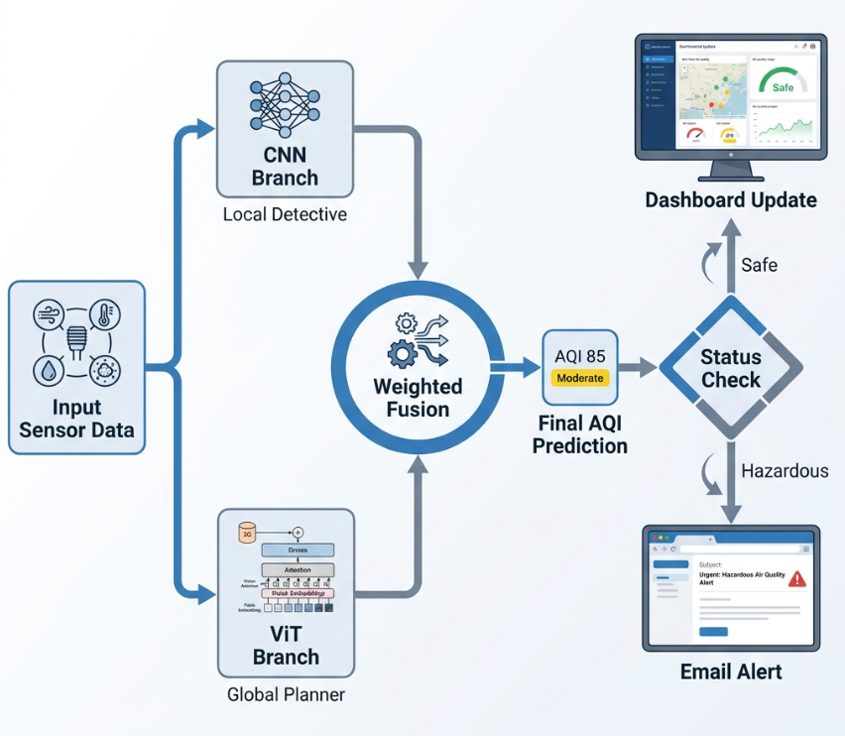
Figure 1: The Hybrid Fusion Architecture. The CNN branch focuses on sharp, immediate deviations, while the ViT branch ensures the prediction aligns with broader environmental trends.

3.2.1 Mathematical Framework of the Hybrid Architecture
The intelligence layer of the proposed system utilizes a dual-branch deep learning approach to map a multi-dimensional sensor input vector X to a precise Air Quality Index (AQI) value.

3.2.2 Local Feature Extraction (CNN Branch)
The Convolutional Neural Network (CNN) branch is engineered to identify high-frequency spatial variations within specific urban zones. The feature map, denoted as f_CNN, is derived as follows:
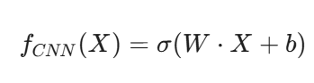
Where:
- W represents the learned convolutional kernel weights.
- b is the bias vector.
- ReLU(·) denotes the Rectified Linear Unit activation function3.2.3 Global Context Analysis (Vision Transformer Branch)
To capture long-range dependencies across the city-wide sensor network, the Vision Transformer (ViT) branch employs a scaled dot-product self-attention mechanism. The input is projected into Query (Q), Key (K), and Value (V) matrices:
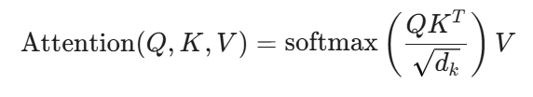
Where dₖ acts as a scaling factor to prevent gradient vanishing during the softmax operation. This mechanism allows the model to assign relative importance to distant sensor nodes, facilitating a holistic understanding of urban pollution trends.

3.2.4 Weighted Fusion and Final AQI Prediction
The outputs from the two branches are integrated through a weighted fusion layer to generate the final predictive output, AQI_final:
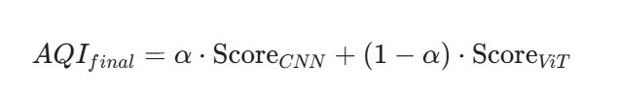
In this implementation, the hyperparameter σ is empirically set to 0.6. This specific distribution reflects a safety-first priority:

- The CNN (60% weight) acts as a Local Detective, identifying immediate risks in specific zones.
- The ViT (40% weight) acts as a Global Planner, ensuring the overall prediction remains stable and consistent with the city’s general air quality state.

3.3 The Application Layer
The technical implementation is designed for speed and scale:
- Backend: Node.js & Express.js for non-blocking I/O.
- Frontend: Vanilla JavaScript for zero-dependency speed.
- Visualization: Leaflet.js maps that provide immediate geospatial context.

4. Results
We put the system through a series of stress tests to see how it handled the chaos of simulated urban life.

4.1 Comparative Performance
We compared our Hybrid approach against standalone models. As shown in Table 2, our model achieves a balance between sensitivity and stability.

Table 2: Performance Comparison.
Metric | Standalone CNN | Standalone ViT | Hybrid (Ours)
Spike Detection | Excellent | Poor | Excellent
Trend Stability | Low (Noisy) | High | High
False Positives | Frequent | Rare | Low
Response Time | <1s | ~2s | ~1.5s

Table 2: Performance Comparison. The Hybrid model successfully retains the spike detection inherent to CNNs while smoothing out noise using the ViT's context.

4.2 Real-Time Visualization & Alerts
The dashboard proved capable of handling high-frequency updates without lag. The alert system was particularly effective. During a simulated "Industrial Leak" event, the system followed the response flow depicted in Figure 2:
1. Detected the AQI spike within 5 seconds.
2. Classified it as "CRITICAL" (Red Status).
3. Dispatched an email alert to the subscriber list relative to that zone.
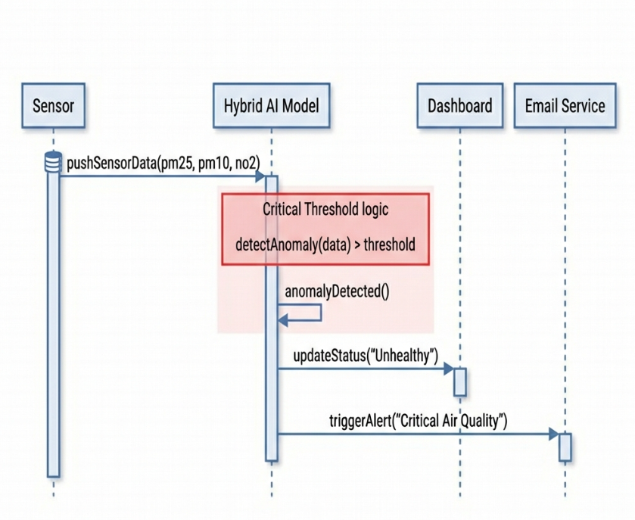
Figure 2: System Response Flow during a Critical Event.

5. Conclusion
This study wasn't just about building a better calculator; it was about building a better safety net. By successfully marrying the "here and now" focus of CNNs with the "big picture" view of Vision Transformers, we've demonstrated a path forward for smarter, safer cities.

Our Hybrid ViT–CNN System proves that we don't need to choose between sensitivity and stability. We can have both. As we look to the future, we plan to take this out of the simulator and into the streets, integrating with physical IoT networks to help real communities breathe a little easier.

6. References
[1] Z. Wang, Y. Yang, and S. Yue, "Air quality classification and measurement based on double output vision transformer," Math. Biosci. Eng., vol. 19, no. 11, pp. 10815–10834, 2022.

[2] T. Zhao and M. Qu, "VDMS: An Improved Vision Transformer-Based Model for PM2.5 Concentration Prediction," Preprints, 2024.

[3] K. S. Reddy et al., "Air Quality Index Prediction Model Using Temporal Fusion Transformer," Int. J. Intell. Syst. Appl. Eng., vol. 12, no. 2, pp. 123–132, 2024.

[4] J. Kim and H. Kim, "A CNN-LSTM-Attention Hybrid Modeling for Hourly PM2.5 Prediction," Atmosphere, vol. 14, no. 2, p. 345, 2023.

[5] X. Li et al., "High-Precision Air Quality Prediction Using a Hybrid CNN-LSTM-KAN Framework," Sustainability, vol. 16, no. 5, p. 2311, 2024.

